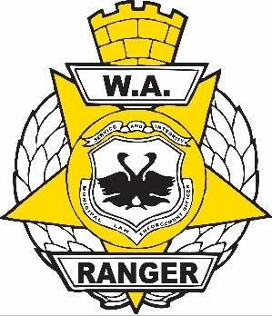
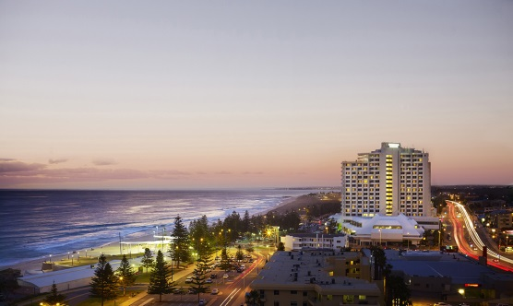
WA Rangers Association
2019 Professional Development Conference

18 & 19 September 2019
Rendezvous Hotel, Scarborough

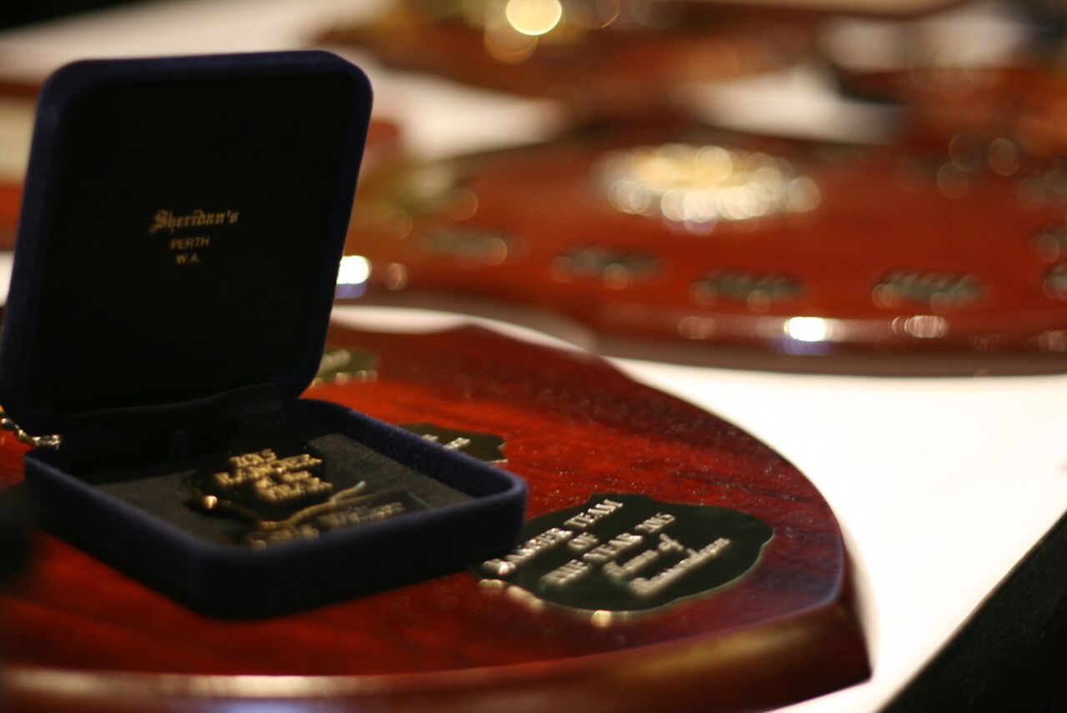

More information can be found on the
WARA website www.warangers.asn.au
on the Annual Training Conference page.

The WA Rangers Association 2019 Professional Development Conference will be held at Rendezvous Hotel, The Esplanade, Scarborough WA on the
18 & 19 September 2019.

To nominate, please complete the Nomination form and send to conference@warangers.asn.au

Awards Dinner – will be held on Wednesday 18 September 2019 at 7pm.

Nominations are now available for the
- Ranger of the Year
- Ranger Team of the Year
- Long Service Awards
.

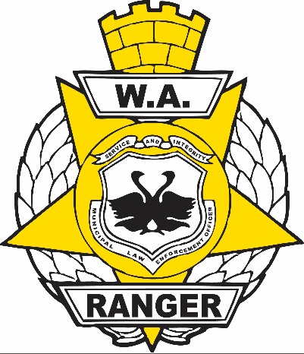
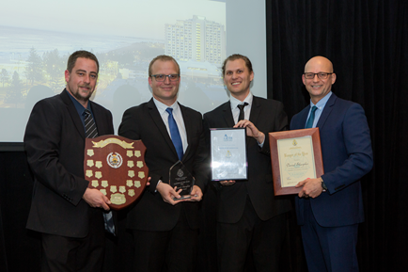
WA Rangers Association
2019 Ranger of the Year Award
2018 RANGER OF THE YEAR
Daniel Sharples, City of Nedlands

WA Rangers Association is seeking submissions from Local Government and members of the public for the 2019 WA Ranger of the Year Award.

This annual Award recognises deeds and achievements by Local Government Rangers that are over and above the call of duty.

The Ranger of the Year will receive an Award, a distinctive medallion specifying “Ranger of the Year”, $500 cash, equipment or services to the value of $500 and a plaque for their employer.

Additional nomination forms can be obtained from www.warangers.asn.au

Please include as much information as possible regarding the achievements and deeds of the person that you are nominating.

Nominations can be forwarded to:

Ranger of the Year Award

WA Rangers Association
PO Box 6

COMO WA 6952

Or conference@warangers.asn.au

Nominations close 1st August 2019.

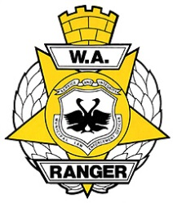
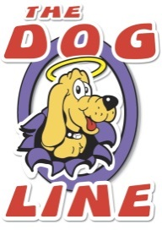
This Award Is Proudly Sponsored By
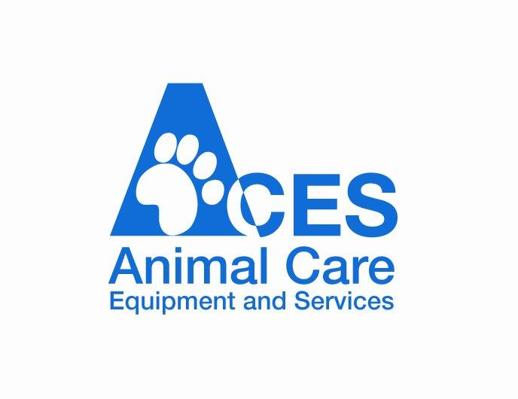

WA Rangers Association
2019 Ranger of the Year Award

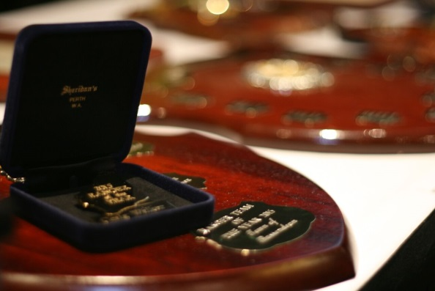
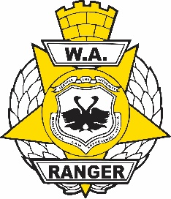

NOMINATION FORM

NOMINEE’S DETAILS

( Mr / Mrs / Ms / Miss ) SURNAME ___________________________________________

GIVEN NAMES ______________________________________________________

ADDRESS __________________________________________________________

PHONE NUMBERS __________________________________________________

EMPLOYED BY ______________________________________________________

POSITION /TITLE ____________________________________________________

NOMINATED BY _____________________________________________________

ADDRESS __________________________________________________________

PHONE NUMBER ____________________________________________________

OCCUPATION / ORGANISATION _______________________________________

PLEASE ATTACH STATEMENTS TO SUPPORT THE NOMINATION

SEND TO

RANGER OF THE YEAR AWARD OR conference@warangers.asn.au
WA RANGERS ASSOCIATION
PO BOX 6
COMO WA 6952

NOMINATIONS MUST BE RECEIVED BY 1ST AUGUST 2019

Late Entries Will Not Be Accepted
Please email this form back to conference@warangers.asn.au

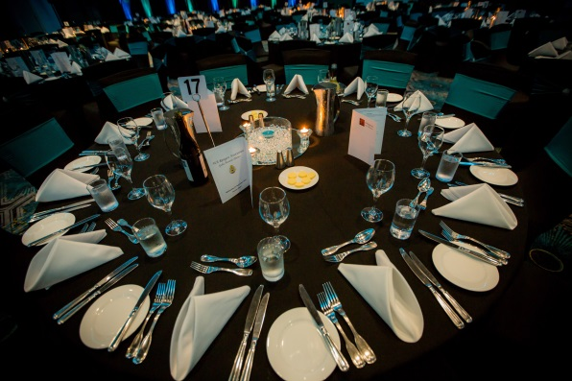
WA Rangers Association
2019 Ranger of the Year Award

- Nominations will be received from any person on the prescribed nomination form, and must be accompanied by supporting documentation.
- WA Rangers Association committee members are eligible; however, nominated awards committee members must stand down from the awards committee and be replaced by another member.
- The award is judged on a points system, with between 1 & 5 points awarded for each selection criteria addressed.
- Written submissions of the nominee must demonstrate;

- Improved public perception of the Ranger and the Local Authority.
- Service to the Community in Ranger core related duties and the benefit to the community.
- Involvement in community education programs.
- The ability to have performed to a consistent high standard of Ranger duties for a minimum period of 6 months.

- The awards committee will verify all supporting documentation and references.

- The WA Rangers Association Awards committee’s decision is final.

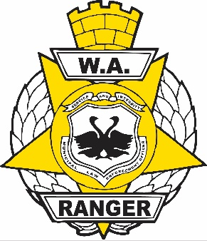
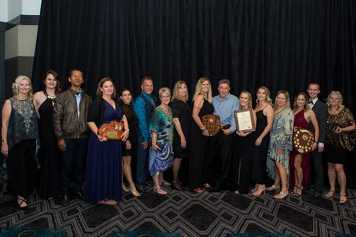
WA Rangers Association
2019 Ranger Team of the Year Award

2018 RANGER TEAM OF THE YEAR
City of Mandurah

WA Rangers Association is seeking submissions from Local Governments for the 2019 WA Ranger Team of the Year Award.

This Award recognises deeds and achievements by Local Government Ranger Teams in the pursuit of excellence in service to the community.

The Ranger Team of the Year will receive,

- A team trophy
- All team members will receive a framed certificate
- A cash prize of $500.
- The teams Council will receive a trophy with all team members listed there-on.
- The team will hold the perpetual trophy

Additional nomination forms can be obtained from www.warangers.asn.au

Please include as much information as possible regarding the achievements and deeds of the team you are nominating.

Nominations can be forwarded to:

Ranger Team of the Year Award
WA Rangers Association
PO Box 6
COMO WA 6952
or
conference@warangers.asn.au

Nominations close 1st August 2019

Proudly Sponsored By

WA Rangers Association
2019 Ranger Team of the Year Award

NOMINATION FORM

NOMINATED TEAMS DETAILS

EMPLOYED BY___________________________________________________

RANGER TEAM MEMBER’S NAMES ____________________________________

______________________________________________________________

______________________________________________________________

ADMINISTRATION STAFF MEMBER’S NAMES _____________________________

______________________________________________________________

NOMINATED BY __________________________________________________

ADDRESS______________________________________________________

PHONE_____________________

OCCUPATION / ORGANISATION_______________________________________

PLEASE ATTACH STATEMENTS TO SUPPORT THE NOMINATION

SEND TO

RANGER TEAM OF THE YEAR AWARD OR conference@warangers.asn.au
WA RANGERS ASSOCIATION
PO BOX 6
COMO WA 6952

NOMINATIONS MUST BE RECEIVED BY 1ST AUGUST 2019

Late Entries Will Not Be Accepted

Please email this form back to conference@warangers.asn.au

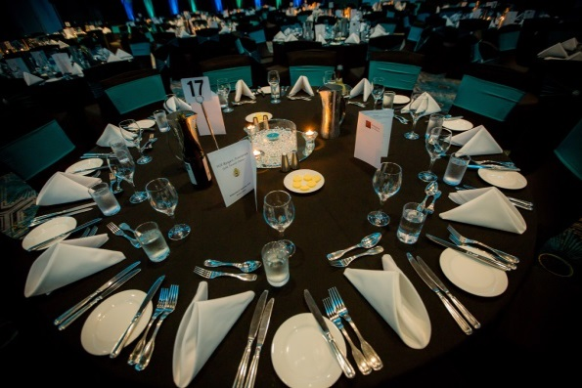
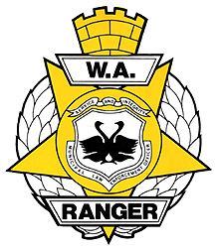
WA Rangers Association
2019 Ranger Team of the Year Award

'For outstanding teamwork, which is of benefit to the community'

- Nominations will be received from any person on the prescribed nomination form and with supporting documentation.

- WA Rangers Association committee members are eligible; however, nominated awards committee members must stand down from the awards committee and be replaced by another member.

- The award is judged on a points system, with between 1 & 5 points awarded for each selection criteria level addressed.

- Selection criteria will include written submissions to demonstrate outstanding teamwork in the following areas over the last 12 months.

- Improved public perception of the ranger team.
- The benefit to the community.
- Examples of outstanding teamwork.
- The entire team effort, including administration staff.
- The results and outcomes.
- Organised building of relationships and partnerships between councils or other key stakeholders.

- The Awards Committee will verify all supporting documentation and references.
- The WA Rangers Association awards committee's decision is final.

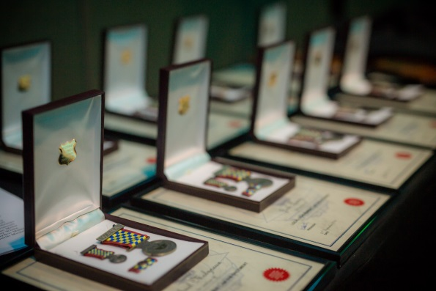
LONG SERVICE AWARDS
Rangers/Parking/Patrol Officers

To recognise the outstanding efforts of dedicated officers who have served in Local Government for ten years or more, the WA Rangers Association acknowledges Long Service.

Medallions for officers who have qualified with ten, fifteen or twenty years and clocks (or similar) for twenty five, thirty, thirty-five or forty years of Law Enforcement Service in Local Government, will be presented during the Training Conference Annual Dinner.

The WA Rangers Association will pay the costs for the Award or Medallions for Officers that have been financial members for the last three (3) years.

For all other applications there is a $250.00 medallion fee.

If you have an officer in your organisation who qualifies for Long Service recognition, please complete the nomination form and forward together with a purchase order if applicable to:

WA Rangers Association
PO Box 6
COMO WA 6952
conference@warangers.asn.au

APPLICATIONS CLOSE 1ST AUGUST each year

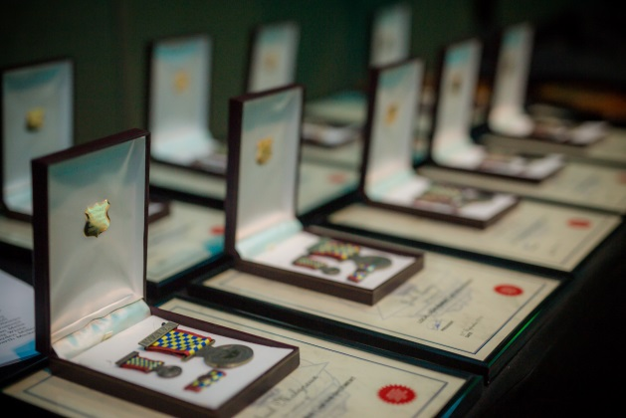
LONG SERVICE AWARDS
Rangers/Parking/Patrol Officers

APPLICATION TO
ACKNOWLEDGE LONG SERVICE
RANGERS/PARKING/PATROL OFFICERS

NAME OF COUNCIL____________________________________________________________

ADDRESS_______________________________________________________________________

_______________________________________________________________________________

CONTACT PERSON______________________________________________________________

NAME OF RECIPIENT____________________________________________________________

TITLE/POSITION_________________________________________________________________

PERIOD OF SERVICE 10, 15, 20, 25, 30, 35, 40 YEARS

SERVICE DETAILS________________________________________________________________

_______________________________________________________________________________

DUTIES_________________________________________________________________________

_______________________________________________________________________________

OTHER COMMENTS_____________________________________________________________

SIGNED BY
CHIEF EXECUTIVE OFFICER_____________________________________

DATED_______________________________

Return together with cheque/purchase order if applicable to:

WA Rangers Association
PO Box 6
COMO WA 6952
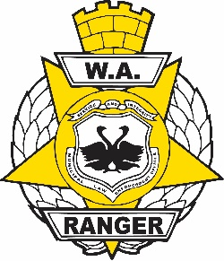
conference@warangers.asn.au
For more information, please don’t hesitate to contact;

WA Rangers Association Inc.
ABN: 15 827 359 591
PO BOX 6 Tel: 04668 475 675
Como 6952
WESTERN AUSTRALIA E-mail: conference@warangers.asn.au

